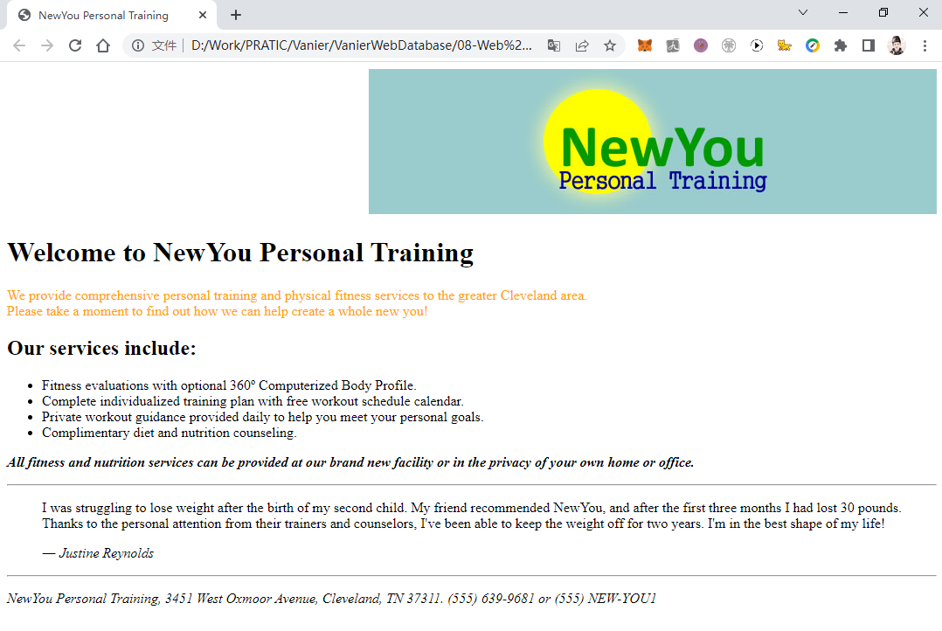

<!DOCTYPE html>

<html>

<head>

    <!--

    Mid Term Web Programming

    NewYou Personal Training

    Author: Qingjun Bao

    Date  : 2022-07-13

    Filename:         Training.html

    Supporting files: logo.jpg

    -->

    <style>

        html {

            font-family: Times New Roman, sans-serif;

            font-weight: normal;

        }

    </style>

    <title>NewYou Personal Training</title>

</head>

<body>

    <div style="text-align: right;">

        <img src="./logo.jpg" alt="NewYou Personal Training">

    </div>

    <div>

        <h1>Welcome to NewYou Personal Training</h1>

    </div>

    <div>

        <p style="color: orange;">

            We provide comprehensive personal training and physical fitness services to the greater Cleveland area.

            <br>

            Please take a moment to find out how we can help create a whole new you!

        </p>

        <h2>Our services include:</h2>

        <ul>

            <li>Fitness evaluations with optional 360&ordm; Computerized Body Profile.

            </li>

            <li>Complete individualized training plan with free workout schedule calendar.

            </li>

            <li>Private workout guidance provided daily to help you meet your personal goals.

            </li>

            <li>Complimentary diet and nutrition counseling.

            </li>

        </ul>

        <p>

            <b><i>

            All fitness and nutrition services can be provided at our brand new facility or in the privacy of your own home or office.

            </i></b>

        </p>

        <hr>

        <p>

            <dl>

            <dd>

            I was struggling to lose weight after the birth of my second child. My friend recommended NewYou, and after the first three months I had lost 30 pounds.

            </dd>

            <dd>

            Thanks to the personal attention from their trainers and counselors, I've been able to keep the weight off for two years. I'm in the best shape of my life!

            </dd>

            </dd>

            <dd>

                <p>

                <author> <i> &#8213; Justine Reynolds </i></author>

                </p>

            </dd>

            </dl>

        </p>

        <hr>

        <p>

            <address>

            NewYou Personal Training, 3451 West Oxmoor Avenue, Cleveland, TN 37311. (555) 639-9681 or (555) NEW-YOU1

            </address>

        </p>

    </div>

</body>

</html>

